PROJECT REPORT

~ 2018 ~

Student: OUSSAMA LGHACHI

Class: Din18sp

Oulu University of applied science

**1 Introduction**

This is my project report.

My name is OUSSAMA LGHACHI and my partner for this project work is Le Quang Huy.

Our project is to write five different math functionalities for the user. Then we make a presentation about our work and the result of these math functionalities.

There are lots of work in this project so we decide to divide them so each person can do what they are best. Then we combine all the work together and provide our opinions so that we can reach a final conclusion about the project.

In this part, my work is to write codes in HTML and CSS to make the web page. Then, I will design our web page so that it will have a nice background with good UI. Also, I will check result of these codes so that they will work perfectly.

**2 The work environment**

The whole work is divided so I and my partner will use most of our time to do at home.

That decision was made since we both have same opinion that we can utilize time at home to do work without noise like we have on class, we also can talk or chat via the Internet.

As a result, we do not have to travelling much in cold weather and keep warm and health at home and do our work.

**3 Definition**

In our final result, the product is a web page where user can use for specific purpose:

* Convert number in decimal, octal, binary and hexadecimal system.
* Print a table showing decimals 0-50 in BIN, OCT and HEX systems.
* Calculate combination and permutation.
* Print truth table
* Radom value that examine a specific number appearance.

**4 Implementation**

The math functionalities are created to answer some math questions:

**4.1 Number system conversions**

This tool is created to convert a number into decimal, binary, octal or hexadecimal systems.

**4.2 Number system output**

In this work, the system will print a table showing decimals 0-50 in BIN, OCT and HEX systems.

Also, user can click “Clear” button to delete this table

**4.3 Combinatorics**

This tool is created to calculate either combinations or permutations.

If users choose “Combination”, they must provide “n” and “k” elements, then the system will give the result. And if the users choose “Permutation”, they can choose with or without “Replacement” using different formulas, and the result is also different; In addition, they need to type in for “n” and “k” element before clicking “calculate”.

**4.4 Truth table**

A basic set of truth tables for basic operations is created.

To finish the task, a knowledge of the basic truth table symbol character codes (HTML / Unicode etc.) is required and we cannot use hard coding in this exercise.

**4.5 Random value**

This tool is created to test random number distributions.

User can choose any range of number in decimal system. Then they can click at “random” button to choose as many random result in the range of minimum and maximum number as they wish. Finally, they can choose any number and see how many times the chosen number has appeared.

**4.6 Programing and decorating with HTML and JavaScript**

These are pictures our final codes in HTML, CSS and JavaScript.

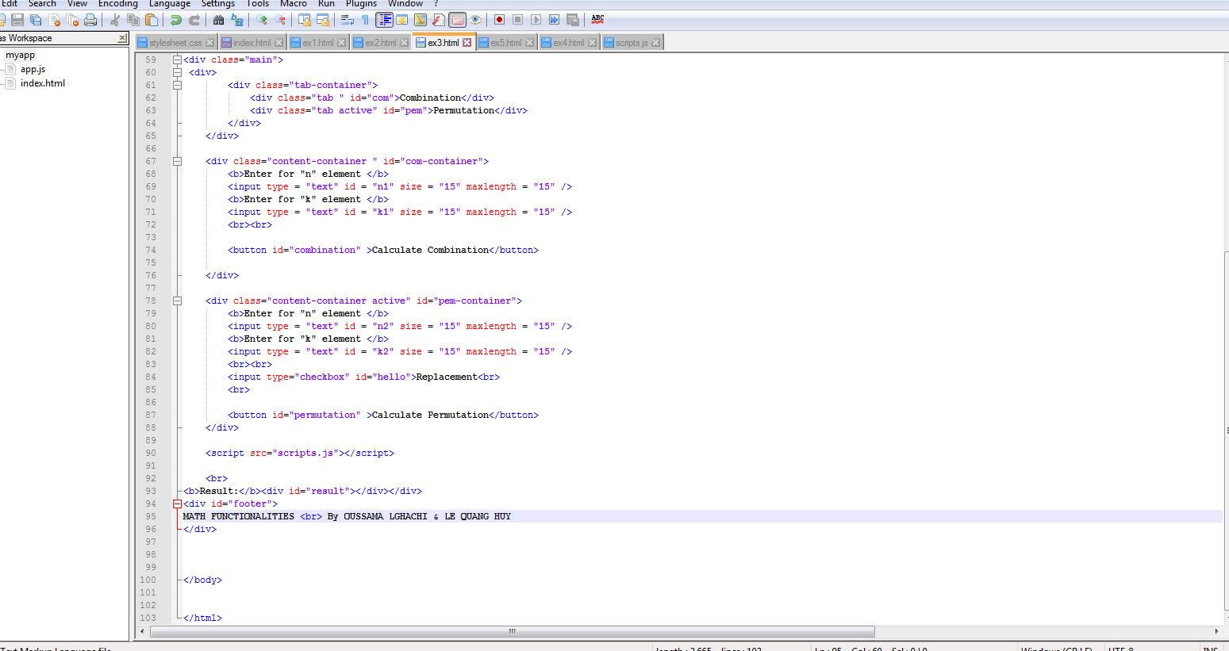

*PICTURE 4.1: code for a math functionality.*

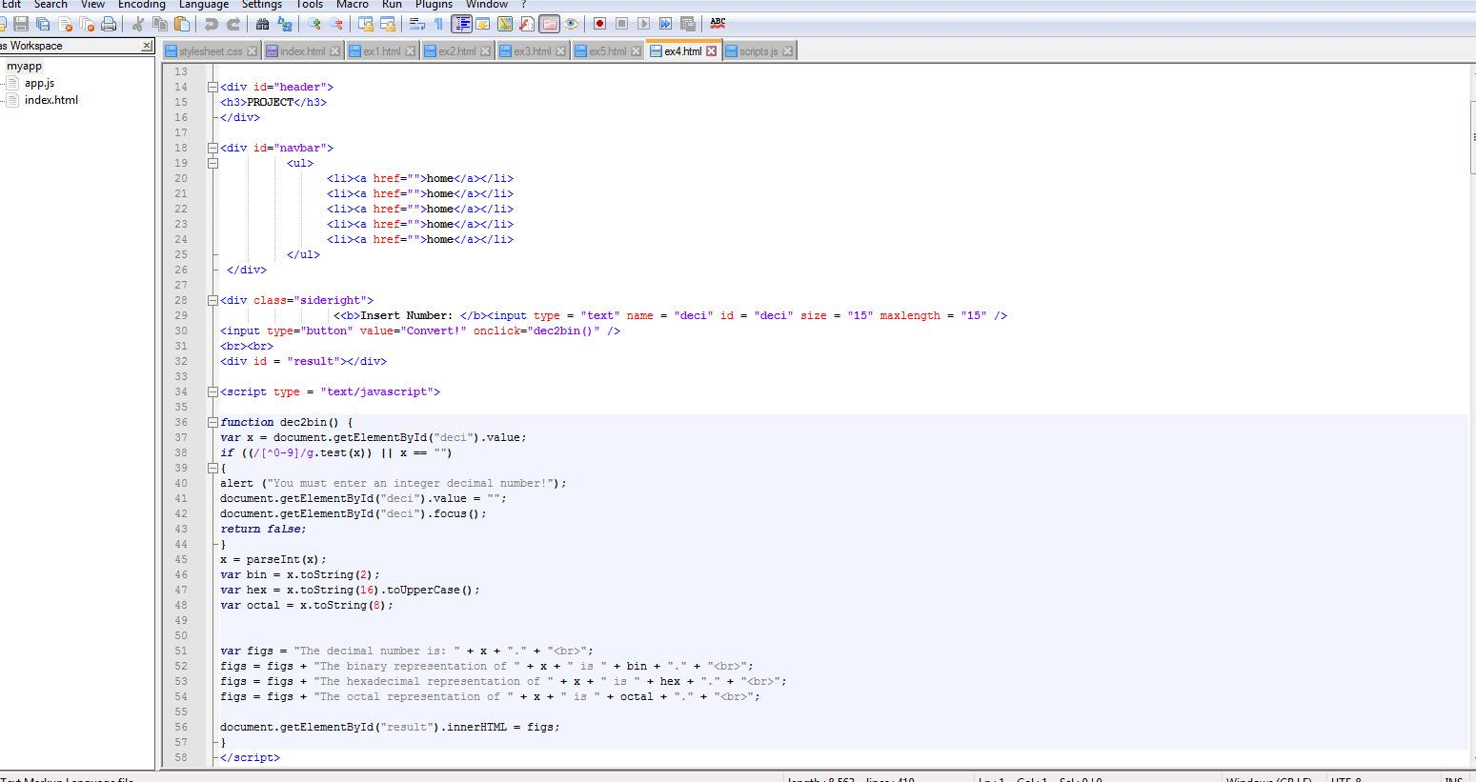

*PICTURE 4.2: code for a math functionality and some for background.*

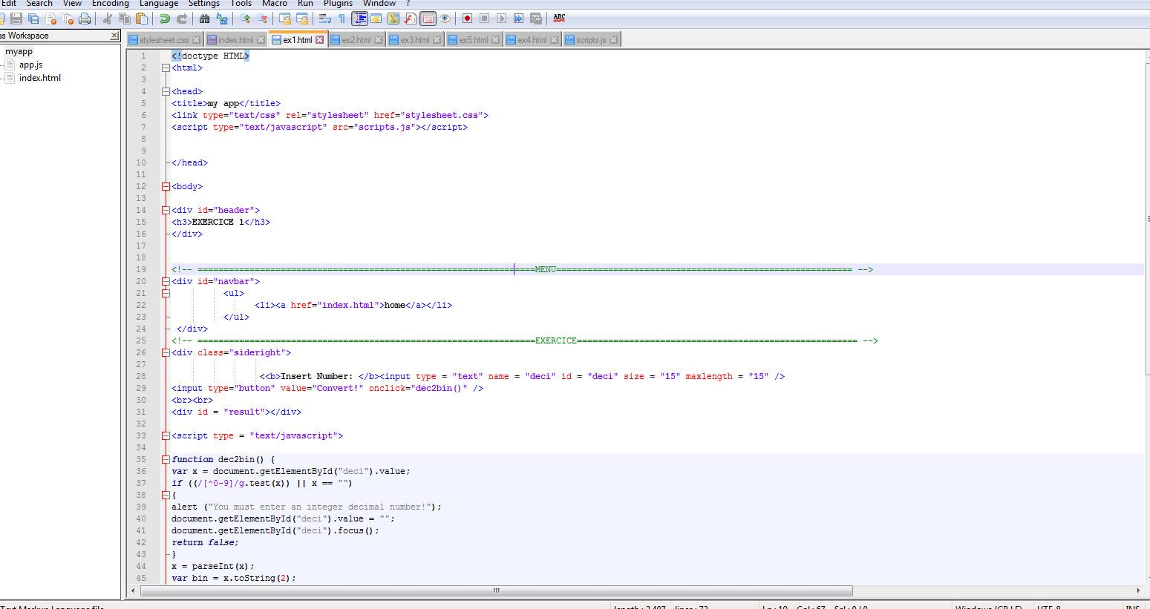

*PICTURE 4.3: A part of final code for web decoration.*

**5 Testing**

For each task, I usually test them several times before our final code product. Then I will put the JavaScript codes of Huy and combine with my web page so that the codes will work perfectly in our website.

**6 Results**

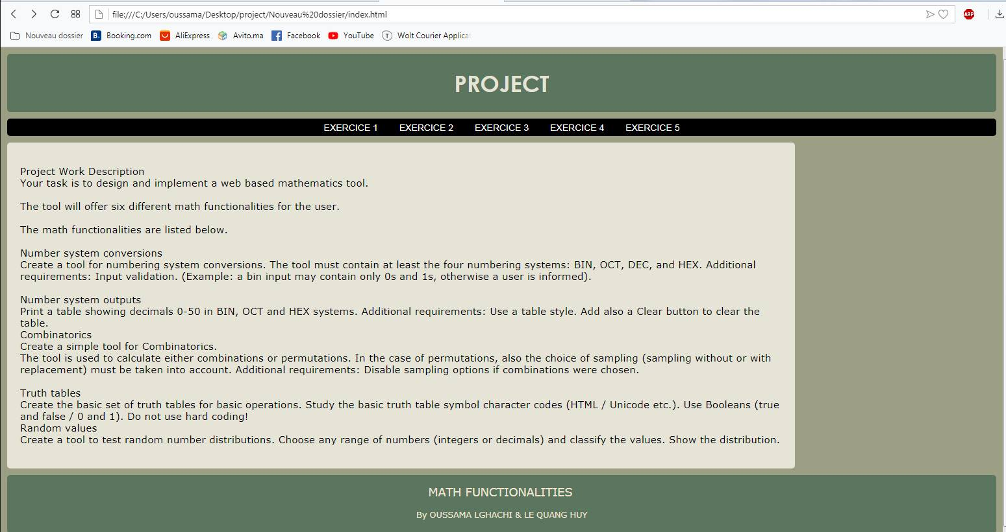

*PICTURE 6.1: First web page*

My main work is designing web and making structure and decoration for web page, after that we - me and my partner - combine all of tasks and web page together.

**6.1 Number system conversions**

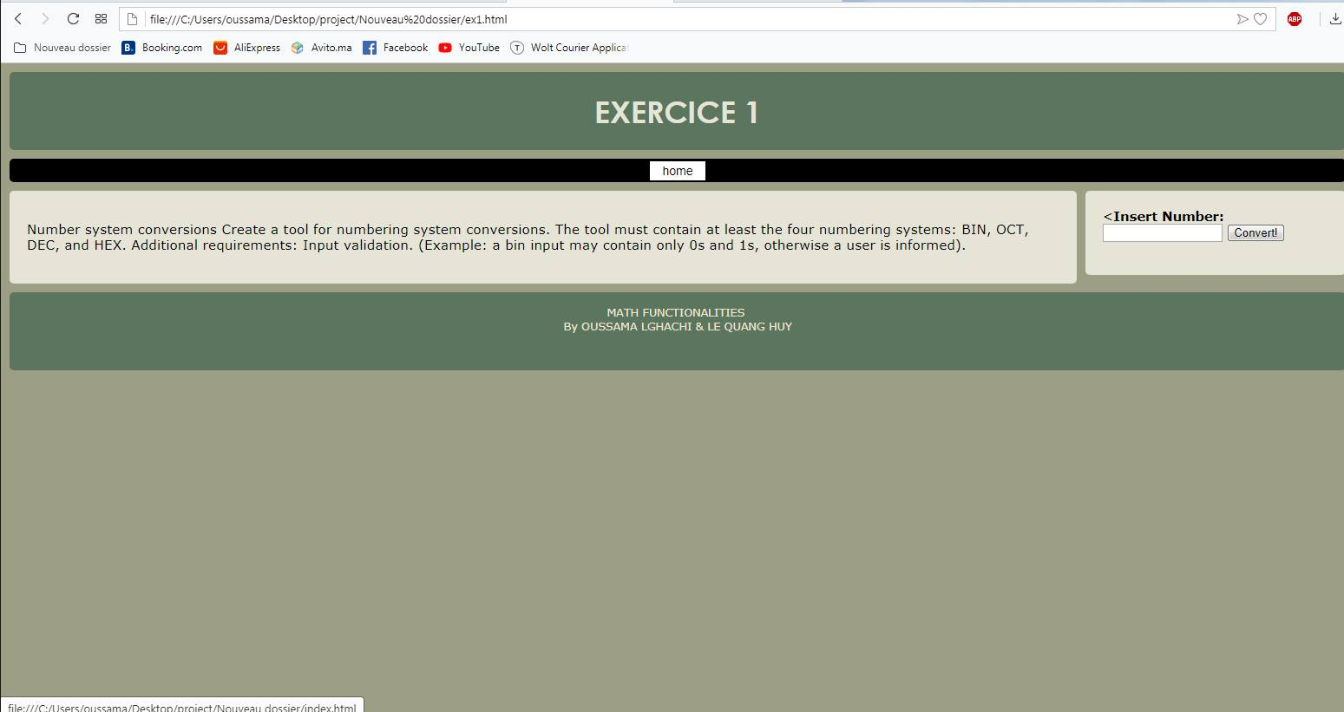

*PICTURE 6.2: Web page with description and math functionality.*

**6.2 Number system output**

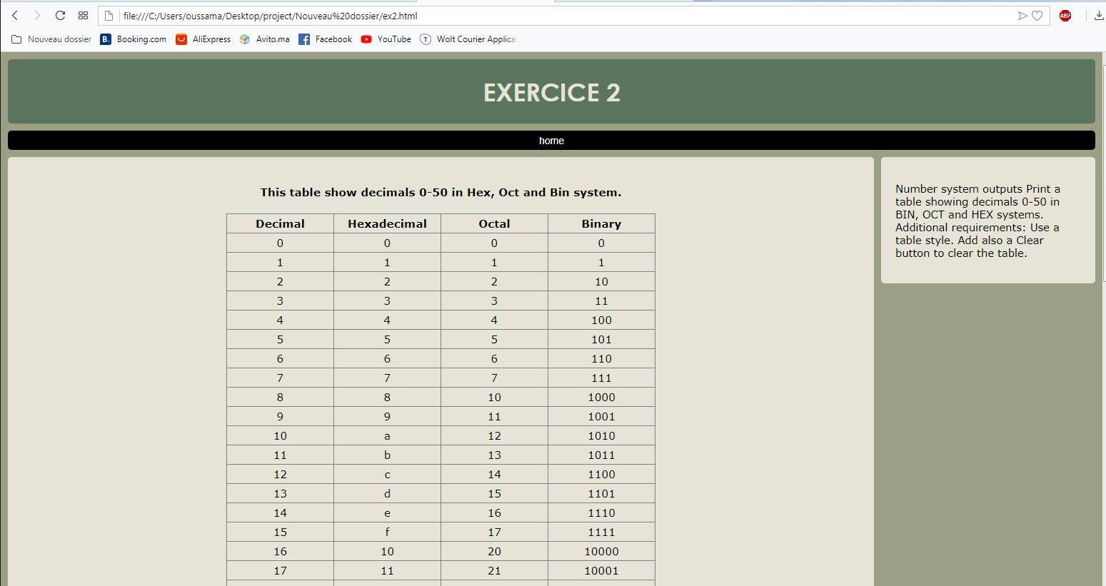

*PICTURE 6.3:* *A printed table showing decimal 0-50 to Binary, Hexadecimal and Octal system.*

**6.3 Combinatorics**

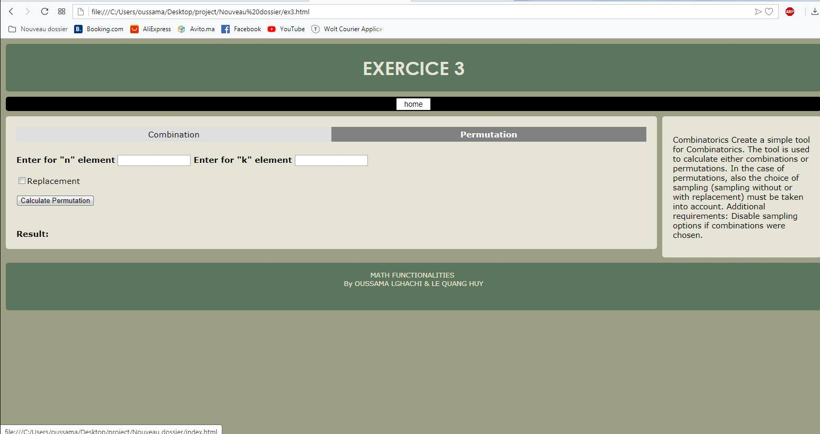

*PICTURE 6.4: The calculator of combination and permutation.*

**6.4 Random value**

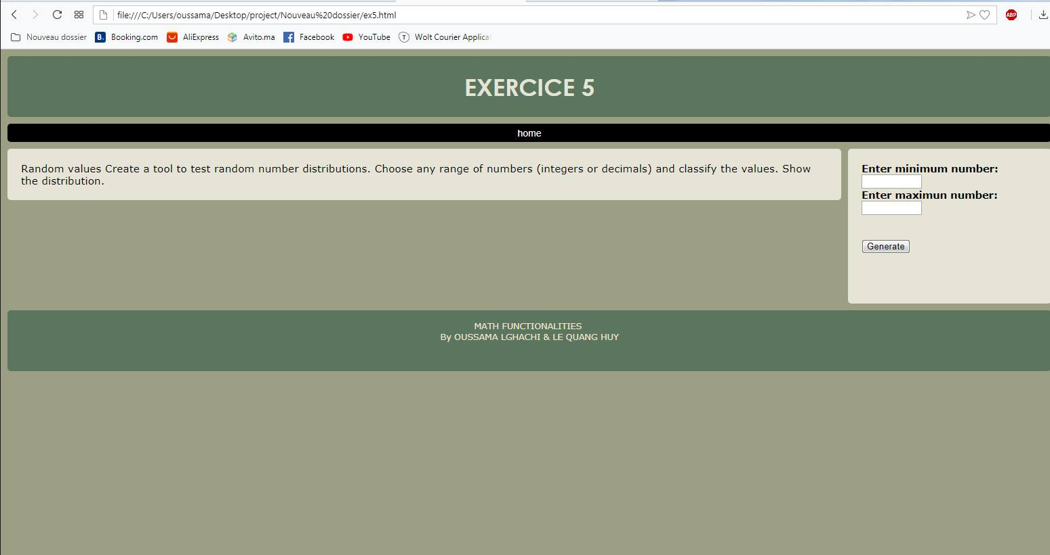

*PICTURE 6.5:* *The “random value” system.*

**7 Reference**

<http://www.ee.surrey.ac.uk/Projects/CAL/digital-logic/gatesfunc/>, logic for truth table

<https://mathigon.org/world/Combinatorics> , math formulas for combination and permutation.

<https://www.rapidtables.com/math/number/Numeral_system.html>,

Number conversion.

<https://stackoverflow.com/questions/28974100/print-range-using-for-loop-javascript>, How to create a range using “for” in JavaScript.

<https://stackoverflow.com/questions/21375398/how-to-print-table-using-javascript> , How to print table using JavaScript?

**8 Conclusion**

The truth is that I found some difficulties with HTML and CSS programing; however, I still try hard to finish my part of tasks and web page.

As a result, everything is done but it takes lots of time for five tasks in project work.

The programing is not too hard; however, it might be a great challenge with someone who does not have any knowledge.

Nevertheless, hard-working is the only solution for any matter which people cannot use talent.